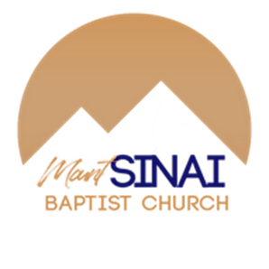
Then I will give you shepherds after my own heart, who will lead you with knowledge and understanding (Jeremiah 3:15)

Mt. Sinai Missionary Baptist Church seeks a dedicated and visionary Senior Pastor to lead our congregation in ministry, service, and community outreach. Our ideal pastor loves God, and loves the people of God, and is committed to kingdom-building.
About Us:
We are a historic and faith-filled congregation that has served the community since 1871. While located in Durham, NC, we are within Orange County. We are surrounded by parts of Duke Forest, and long-standing as well as new communities. Over the years, we've continued and grown with the support of our dedicated pastors, members, and community.
We are actively involved in the New Hope Association of the General Baptist State Convention. From humble beginnings, Mt. Sinai continues to stand as a beacon of faith, service, and love. Come be a part of our faith journey!
How to Apply:
Please contact Deacon Sharon W. Williams for more information at (919) 219-8389 or pastoralsearch@mtsinaidurham.org. You can also submit a cover letter and resume to Deacon Williams at: pastoralsearch@mtsinaidurham.org
We hope to begin review of applications on March 31, 2025. However, applications will be received until the position is filled. We are prayerful that our pastor will be in place in the year of our Lord 2025.
Come be our shepherd as we continue to grow in faith, serve our community, and share God’s love with the world!

More information @ www.mtsinaidurham.org

